Literacy

Maths

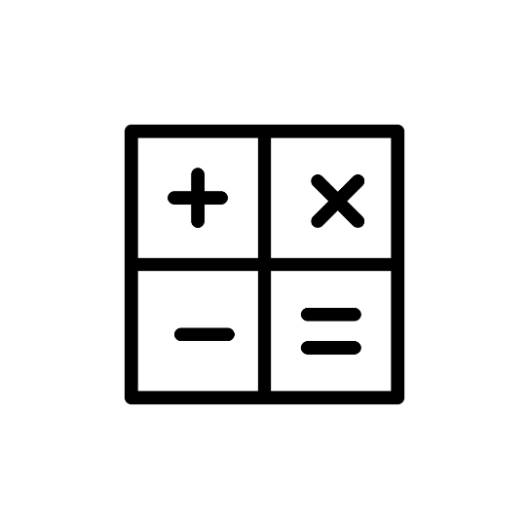



Silent Reading

Guided Reading





Spelling

Writing



Science

P.E

History

Geography



ICT

R.E

Register

Golden Time

Home Time

Circle Time

Lunch

Break

Library

Singing

Surprise

Visitor

School Trip

Story Time

Tidy Up

Wash Hands

**Outdoor Learning**

IDL

**Health & Wellbeing**

Soft Start

Comprehension

Grammar

Topic

Finishing Off

Mindfulness

Drama

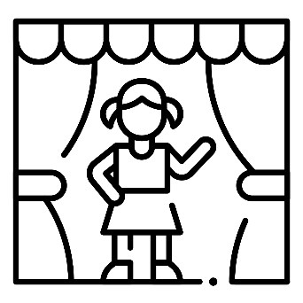

Handwriting

Assembly

Spanish

French

Music

Art